CS685 Homework1
By Purushottam Sharma
Question 1:
a). ROTATION:
det(T1)= 1
b). TRANSFORMATION:
As the transpose of the matrix is equal to its inverse, T2 is orthogonal.
det(T2)= -1

c).Difference between T1 and T2:
- det(T1)= 1 and det(T2)= -1
- T2 is not a rigid body transformation, but T1 is. The distance between all the points as well as the orientation of the triangle in fig.1 is preserved. While in fig. 2, though the distances are preserved but the orientation is not, which is not a characteristic of Rigid Body Transformation.
- OUTPUT:
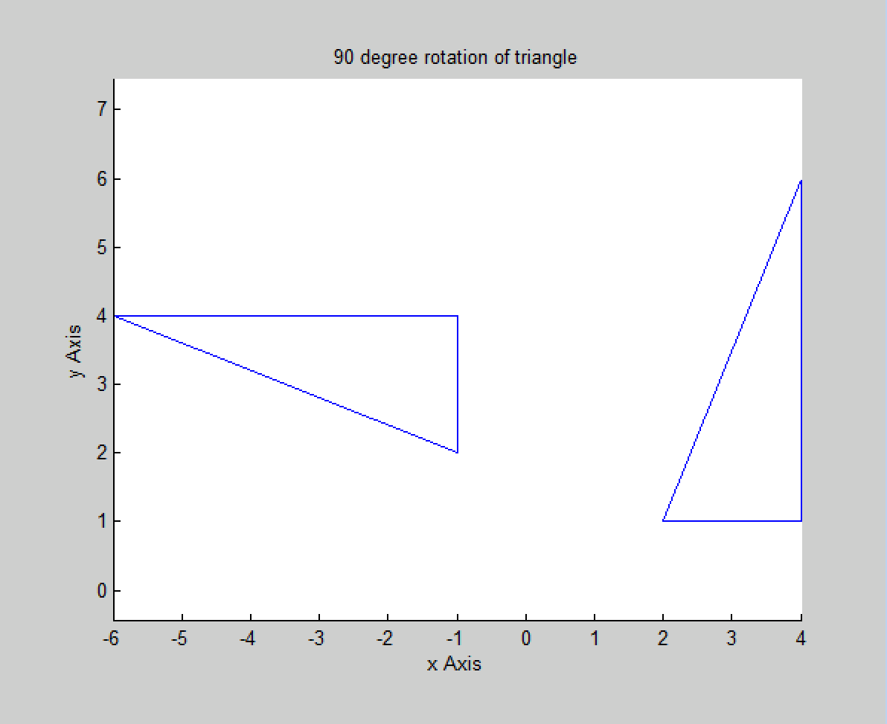
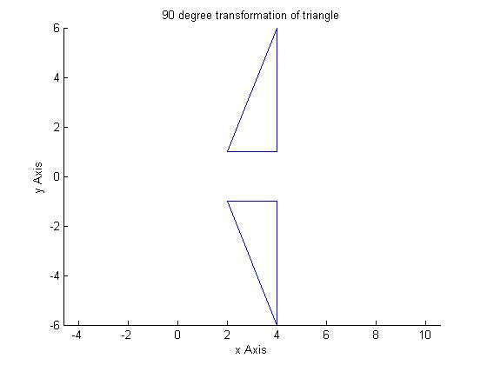

Question 2:

Question 3:

Question 4:

angle= 1.8138 radians ~ 104º

Eigen vector associated with the unit eigenvalue is. It's physical significance is that it is the axis of rotation. The unit eigenvalue keeps all the points on the vector unvaried over the transformation.
Question 5:

